




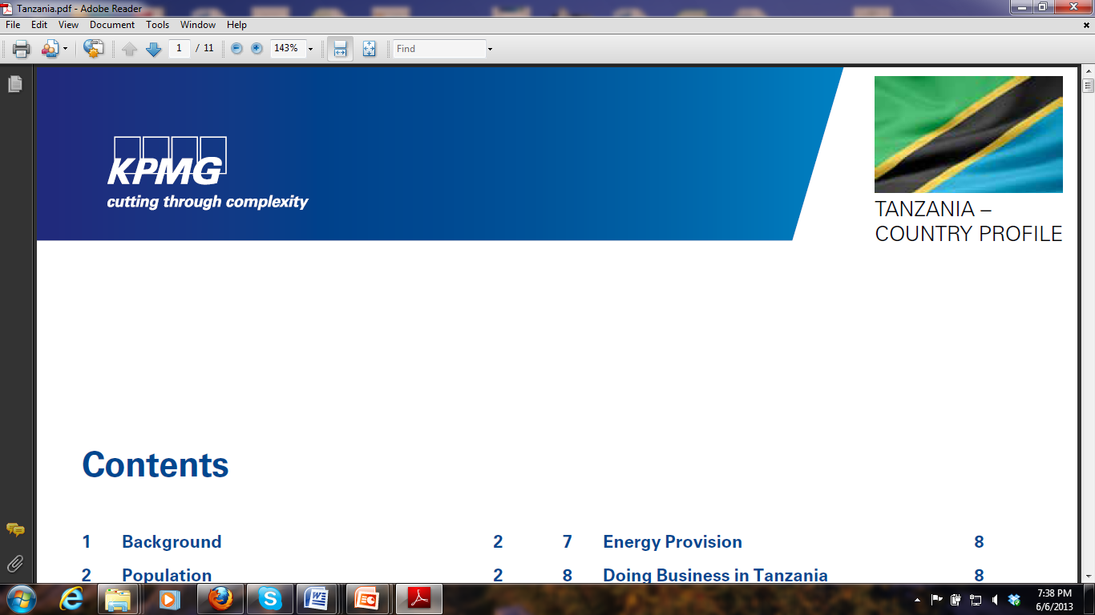
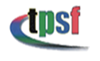
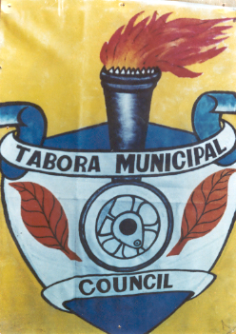
TABORA INVESTMENT FORUM
19th JULY, 2013, SERENA HOTEL, DAR ES SALAAM

The Tabora Investment Forum will provide potential domestic and foreign investors, as well as intermediaries, with information on investment opportunities and the investment climate in Tabora.

Tentative Programme
TIME | EVENTS | RESPONSIBLE
08:00 – 09:00 | Registration of participants | Participants
09:00 – 09:15 | Arrival of the guest of honour | Chairperson/RC
09:15 – 09:20 | Welcome speech by the chairperson of the Investment Forum Organizing Committee | Hon. Samwel J. Sitta (MP), Minister for East Africa Community,  Chairperson of the event
09:20 – 09:30 | Welcome speech by the Regional Commissioner of Tabora | Hon. Fatma A. Mwassa,  Regional Commissioner
09:30 – 09:40 | Millennium Cities Intiatives Program and Regional Partnership Project | Dr. Moumié Maoulidi,  Associate Director,  Millennium Cities Initiative (MCI)  The Earth Institute at Columbia University, New York
09:40 – 09:50 | The Regional Partnership to Promote Trade and Investment in Sub-Saharan Africa, funded by Government of Finland | Ms. Sari Laaksonen, Commercial Secretary for Trade and Development, Ministry of Foreign Affairs, Finland
09:50 – 10:00 | Address from the private sector | Mr. Aloys Mwamanga,  President of Tanzania Chamber of Commerce, Industry and Agriculture
10:00 – 10:10 | Address by the Minister and introduction of the guest of honour | Hon. Dr. Mary M. Nagu (MP), Minister for Investments
10:10 – 10:30 | Speech by the guest of honour and official launching | Guest of Honour  Hon. Dr. Mohamed Gharib Bilal,  Vice President of United Republic of Tanzania
10:30 – 10:45 | Group photo and coffee break | Participants
10:45 – 11:05 | Presentation on Tabora and government initiatives on improving business climate for investment in Tabora Region | Ms. Kudra Mwinyimvua, Regional Administrative Secretary, Tabora
11:05 – 11:25 | Presentation on investment incentives and facilitation services:  - Tanzanian Investment Centre  - EPZA | Ms. Julieth R. Kairuki, Director, Tanzania Investment Centre  Dr. Adelhem Meru, Director, Export Processing Zones Authority of Tanzania
11:25 – 12:00 | Presentation on potential investment opportunities in Tabora | Dr. Karin Millet and Deo Damian Msilu, Investment Promotion Experts
12: 00 – 12:20 | Question and answer session | Regional Secretariat/Organizing Committee
12:20 – 13:30 | Lunch Break | All
13:30 – 13:45 | Case Study: A Successful Domestic Investor in Tabora | Mr. Amritpal Athwal, Managing Director, Athwals Timber and Transport Company Ltd.
13:45 – 14:00 | Case Study: A Successful Foreign Investor in Tabora | Operation Manager,  Golden Pride (T)
14:00 – 14:15 | Presentation on access to business advisory services | Mr. Salim Bashir, KPMG Tanzania, Country Representative
14:15 – 14:30 | Rappour | Rappourteur
14:30 – 14:35 | Vote of thanks | Hon. Fatma A. Mwassa, Regional Commissioner, Tabora
14:35 – 14:40 | Closing remarks | Hon. Dr. Abdallah Kigoda (MP), Minister for Industry and Trade
14:40 – 15:00 | Coffee break
15:00 – 16:00 | One to one meetings | Organizing Committee
16:00 | Adjournment | Organizing Committee

Moderator: Mr. Taji Lihundi

